**Pascubillo, Dexter G. BSIS I102**

**FINAL LAB TASK 1**  
TASK 1

Create the employees table

* Define employee_id as a unique integer, auto-increment, and primary key.
* Define employee_name as a VARCHAR (up to 255 characters), and make it not null.
* Define manager_id as an integer, which will be a foreign key referencing employee_id from the same table.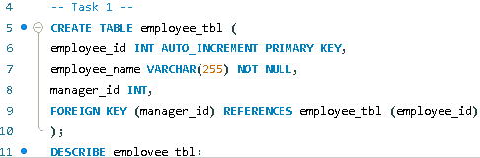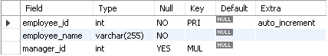

TASK 2

Create the departments table

* Define department_id as a unique integer, auto-increment, and primary key.
* Define department_name as a VARCHAR (up to 255 characters), and make it not null.
* A screenshot of a computer code

  AI-generated content may be incorrect.

TASK 3

Create the employee_departments table

* Define employee_id as an integer, which will be a foreign key referencing employee_id in the employees table.
* Define department_id as an integer, which will be a foreign key referencing department_id in the departments table.
* Set a composite primary key on the combination of employee_id and department_id. A computer screen shot of a computer code

  AI-generated content may be incorrect.A screenshot of a computer

  AI-generated content may be incorrect.

TASK 4

Create the employee_projects table

* Define employee_id as an integer, which will be a foreign key referencing employee_id in the employees table.
* Define project_name as a VARCHAR (up to 255 characters), and make it not null.
* A computer code with text

  AI-generated content may be incorrect.A screenshot of a survey

  AI-generated content may be incorrect.

TASK 5

Create the managers table

* Define manager_id as a unique integer, auto-increment, and primary key.
* Define employee_id as an integer, which will be a foreign key referencing employee_id in the employees table.

EERD MODEL